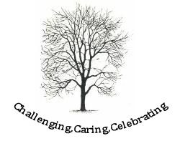
Ashdon Primary School

Delivery of the curriculum and pastoral care

We use personal information, for example:
- Names and address
- Contact details
- Date of birth
- Education attainment
- Emergency contacts
- Family relationships
- General case information.

We also use some special category personal information, for example:
- Health information
- Ethnicity
- Religion.

This information is provided by parent/carers, the local authority and any previous education settings and is used in order to meet our statutory education duties.

The school is the Data Controller for this information.

This information may be shared in order to provide our education service. Please note we only share information required for that particular purpose and then only the minimum required. We may share information with:
- Central & Local Government,
- Health Providers
- Other Education Providers
- Regulatory Bodies, e.g. Ofsted, The Information Commissioners Office.
This information will be held for 25 years from the date of birth of the student. When a pupil changes school, this record will go with them and will not be retained by the previous school, other than to meet statutory returns.

Our school management system is provided under contract and they act as data processors for this information.

No personal information is routinely available outside of the UK. Should a transfer of personal information be necessary we will only do so where it is permitted by law and where appropriate safeguards are in place.

For information about your rights in relation to this use of your personal information please see section 5 of our overarching privacy notice.

© Essex County Council

