Mathletics – A quick guide to getting started

- Use your Internet browser to type in https://login.mathletics.com/
- It will bring you to a screen similar to the one below. Enter the username and password given to your child.

Remember: Each child’s username and password are unique to them. Please keep their login details in a safe place. If you ever lose the information then please contact the school as quickly as possible. Equally, if you feel the accounts security has been compromised, e.g. your child has told other children their login details (!), then please inform us, so that we can alter their password and reissue their login details.

- When your child logs in, they will be presented by the choice of activities that their class teacher has assigned for them. These activities must be completed prior to be able to access any of the other content on the Mathletics website.

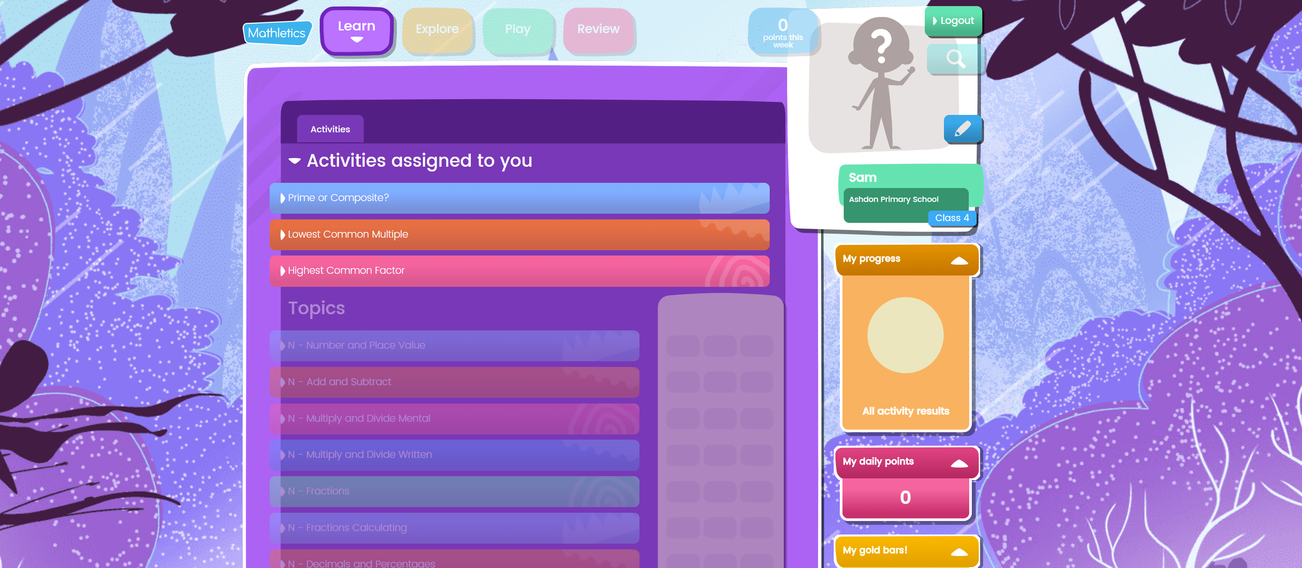

Note: By default, your child will be assigned activities deemed suitable for their year group at school. The class teacher can change this setting to give easier or harder work if required. Please speak to the class teacher if your child has found the mathematics involved in the activities too easy or too hard (Please remember, your child will find some elements of mathematics easier than others, so bear this in mind before speaking to the teacher, only speak to them if the difficulty is consistently different from your child’s ability).

- Click on one of the activities that has been assigned for your child. The screen will then change and will display the first question to complete. Usually the activities have 10 questions in total. To answer a question, you will either need to click on the correct answer or enter answers by typing into a box. Once you are happy with your answer, click on the green ‘submit’ box in the bottom right-hand corner of the screen. Your child will then see either a green tick or a red cross to indicate whether they have answered the question correctly. Click on the ‘next’ box to move to the next question.

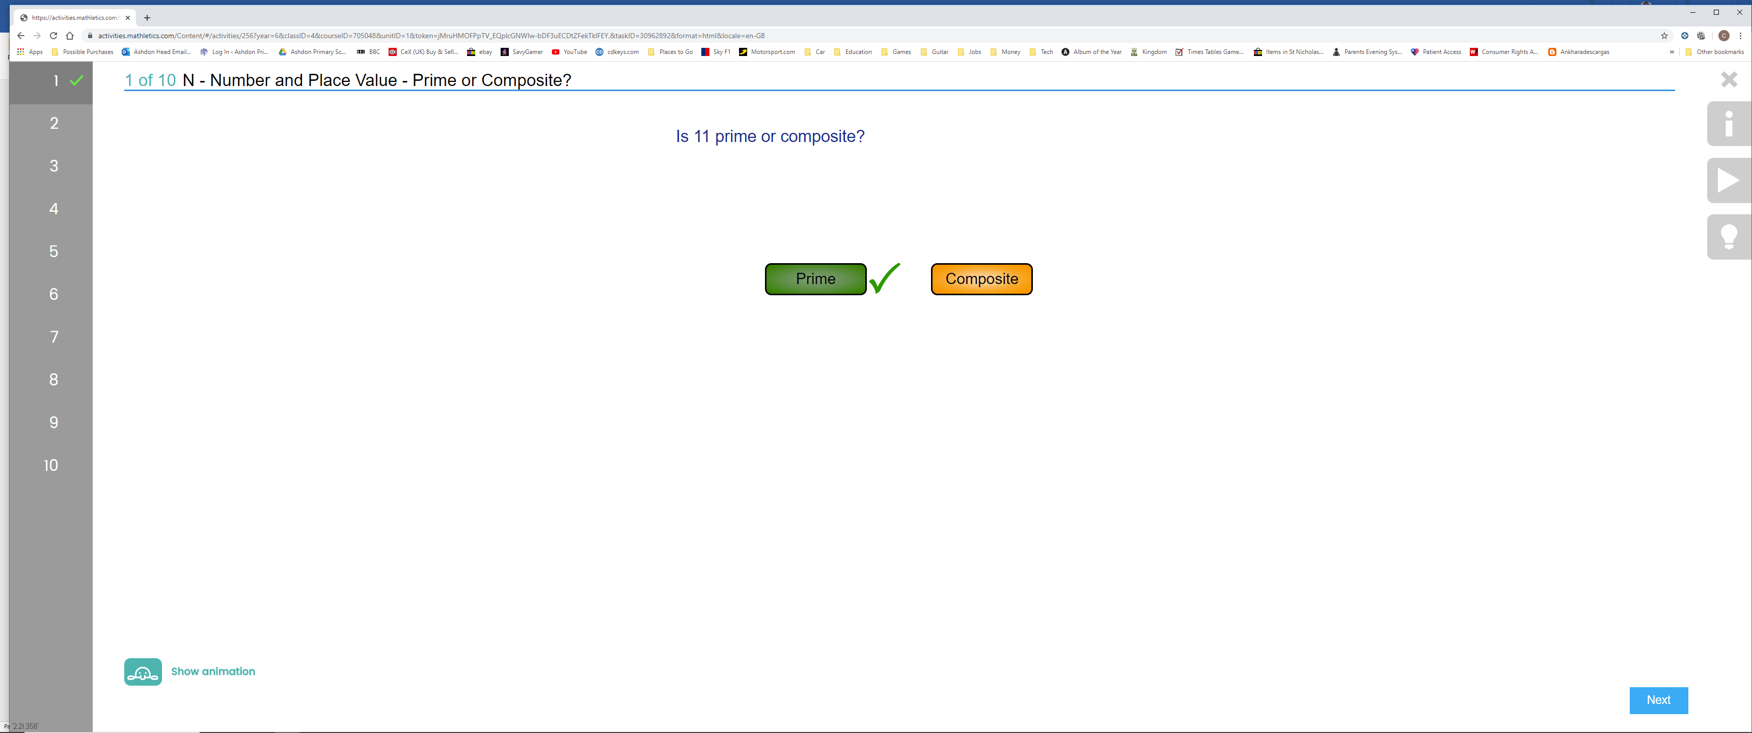

- Once your child has completed all of the questions, they will be told their mark out 10. Please note, if your child doesn’t get 10 out of 10, they can attempt the questions again (the actual questions do get randomised in many of the activities, so they won’t just be able to memorise the answers).

- Click on the grey X on the top-right hand side of the activity screen (not the X on the browser, otherwise you will close the whole thing!). This will then take you back to the main menu, where you will see the points that your child has earnt (10 points per correctly answered question) and any gold bars they have earnt (at least 85% of the questions in the activity have to be answered correctly). You will see any remaining activities to complete.

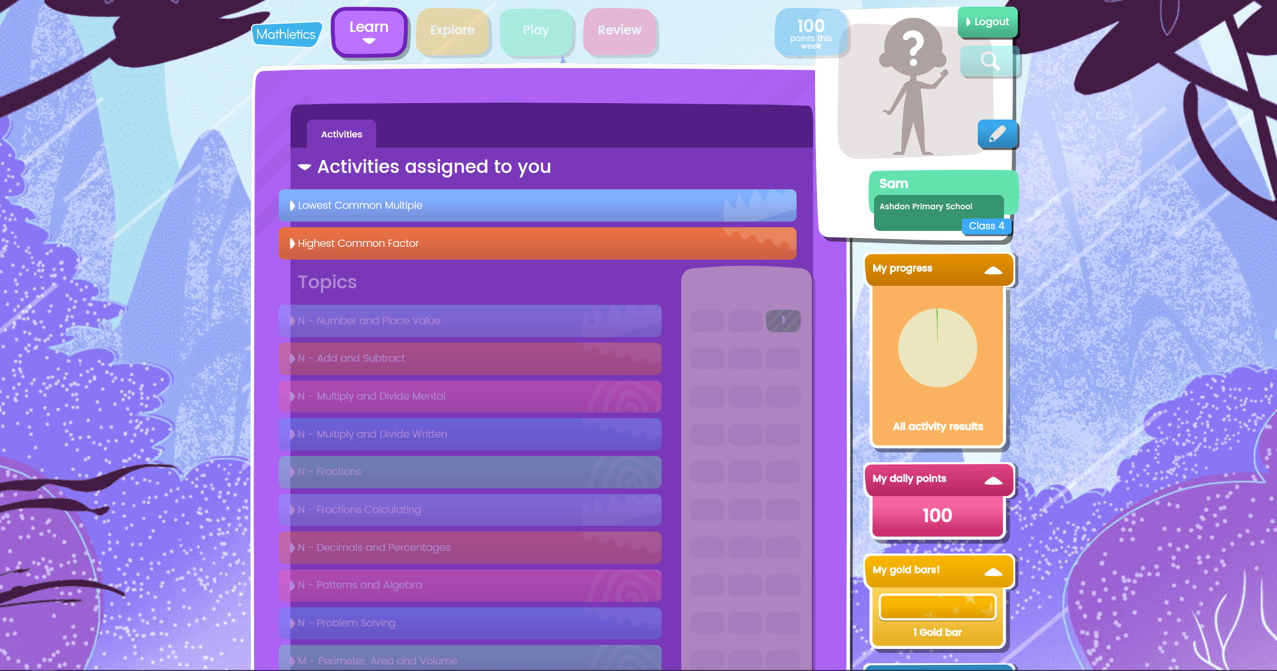

Please note: Until your child has completed all the activities assigned to them, the other features of Mathletics will be inaccessible. For example, they won’t be able to adjust the look of their avatar.

- You can find out more about Mathletics in the Primary Student Experience Guide, that will be sent via email to you from the school office. This goes into more detail about the rewards system (1000 points per week results in a bronze certificate), how the children can alter their avatar using credits earnt by answering the activity questions correctly and many other aspects of the site.

