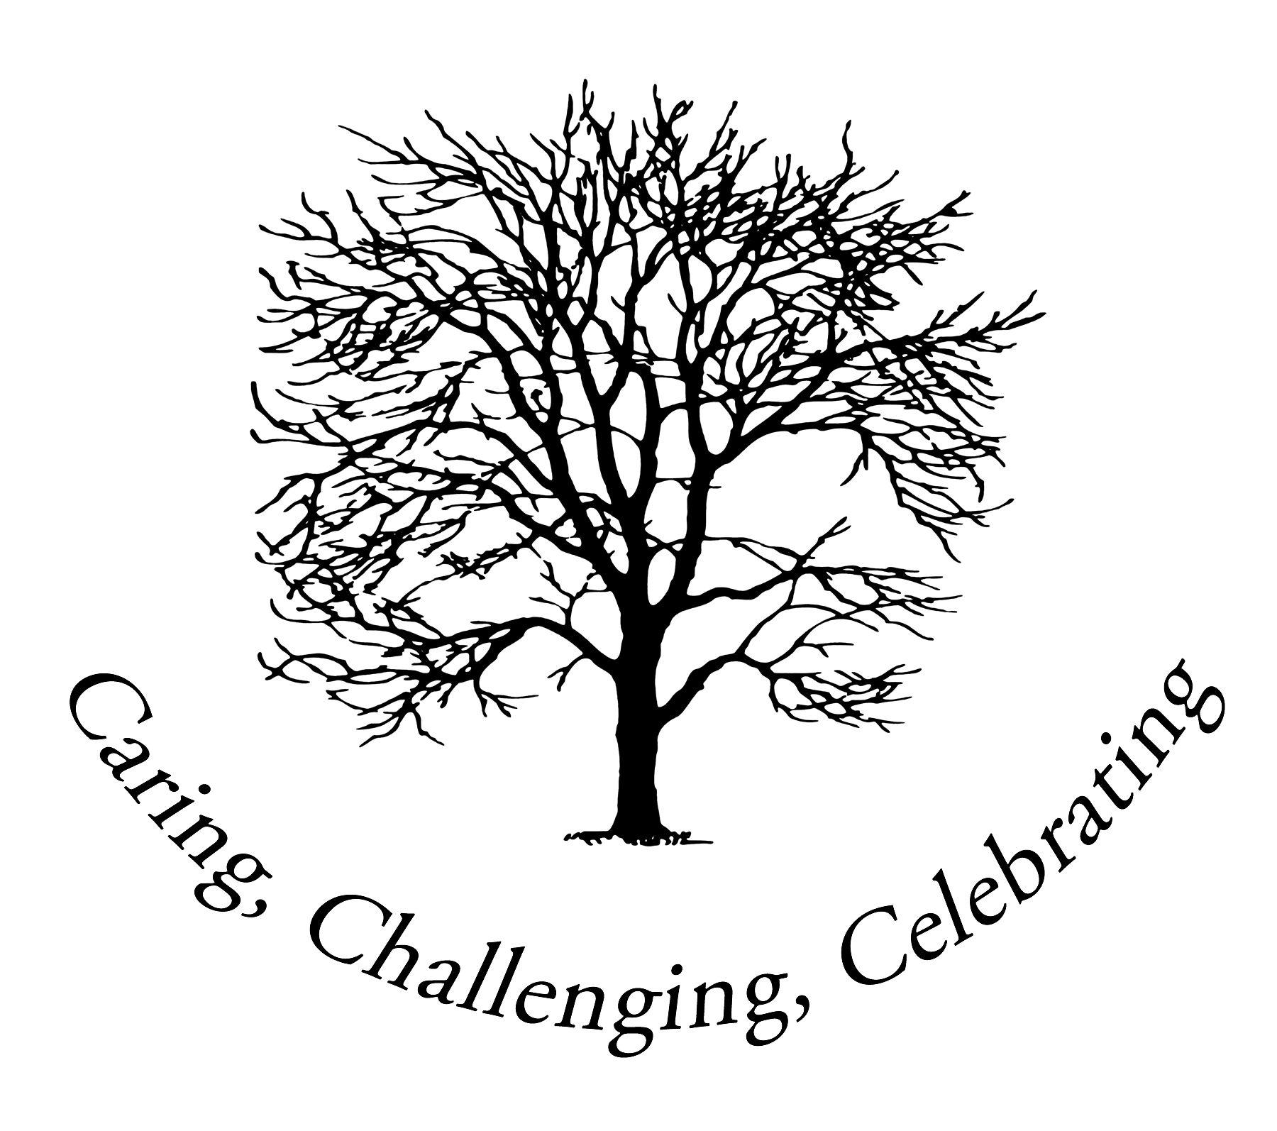

Ashdon Primary School
Ashdon
Saffron Walden
Essex CB10 2HB
Telephone: 01799 584219
www.ashdon.essex.sch.uk admin@ashdon.essex.sch.uk
Headteacher: Mr. S. Rance

D

5th May 2021
Dear parents and carers,

As you will be aware from earlier communications I have sent, Class 3 have covered puberty as part of the science curriculum. During this term, Mrs Lunn will look at this again as part of the RSHE curriculum, which will include physical and emotional changes during puberty and menstruation. All of these aspects are part of the Government’s statutory curriculum, so no child can opt-out of these.

However, there are 2 elements of the RSHE curriculum that are non-statutory, therefore require parent permission for your child to take part. The 2 areas covered will be conception and pregnancy/child birth. The children will learn about the following vocabulary: Sperm, egg, erection, fertilise, conception, sexual intercourse, relationship, pregnancy, commitment, baby, love and care.

If you wish for your child to miss these lessons, then you need to consider how/when your child will learn about these aspects, as there will not be another opportunity at our school. It is important that children have enough understanding and accurate knowledge to make informed decisions that keep them safe as they grow up – this is why the Government recommends that all children participate.

If you are happy for your child to take part in the lessons on conception and pregnancy/birth, then please complete the short form below. However, you may decide that you do not wish for your child to participate in these specific lessons, in which case you need to complete the form on the 2nd page of this letter and return the completed form back to me. Pupils who will not take part in these lessons, will be set alternative work to complete, whilst supervised in another room.

Mrs Lunn plans to teach the lessons on the last week before half term, i.e. w/c 24th May. If you have any queries, then please speak to either Mrs Lunn or myself as soon as possible.

Yours sincerely,

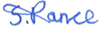
Simon Rance
Headteacher
--------------------------------------------------------------------------------------------------------------------------------------
Please return this form to the school by Monday 17th May at the latest.

Name of child: ___________________________________

I give permission for the above child to participate in the lessons on conception and pregnancy/child birth.

Signed: __________________ Name of parent/carer: _____________________ Date: ________

Parent form: withdrawal from non-statutory Sex Education

To be completed by parents
Name of child |  | Class
Name of parent |  | Date
Reason for withdrawing from the non-statutory Sex Education
Any other information you would like the school to consider
Parent signature

