Essex County Council School Term and Holiday Dates for Community and Voluntary Controlled Schools - Academic Year 2023-2024

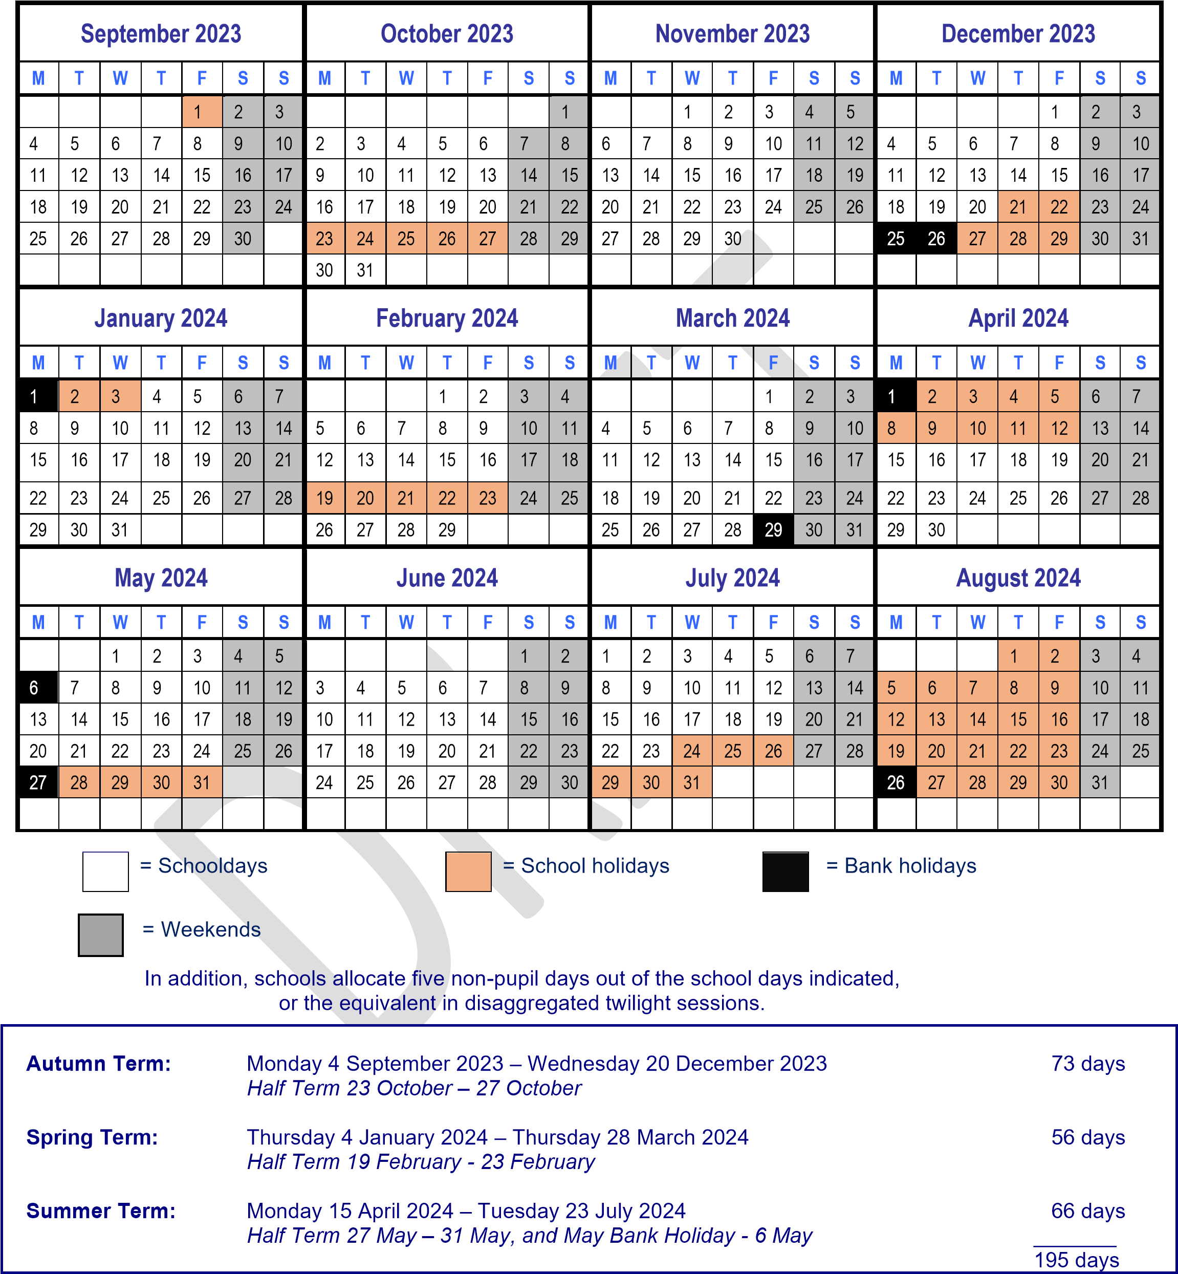
= Professional Development Days (school will be closed)

Please note:
The above dates may vary for individual schools, especially Foundation, Voluntary Aided schools and Academies.
You are strongly advised to check with your child’s school before making any holiday or other commitments.

