Ashdon Primary School

School Uniform Policy

Headteacher | Ms. M Reynecke
Co-Chairs | Mr. K. Henry and Mr. C.Vost
Vice Chair | Mr. P.Wiles
Approved by Governors | 12th October 2023
Review of policy | October 2024

SAFEGUARDING STATEMENT

Ashdon Primary School takes seriously the responsibility to protect the welfare of the children in its care, believing that “The welfare of the child is paramount” Children Act 1989.
This policy plays an integral part in our aim to safeguard the children and ensure their wellbeing in order to promote optimum development.

Introduction
From September 2022, schools have to comply with the statutory guidance from the DfE on school uniforms, under the Education (Guidance about Costs of School Uniforms) Act 2021. This policy aims to show how our school aims to meet these requirements.

Throughout this policy, ‘parents’ should be taken to include all those with parental responsibility, including guardians and carers.

Rationale
Uniform as it can play a key role in:

- promoting the ethos of a school
- providing a sense of belonging and identity
- setting an appropriate tone for education
By creating a common identity amongst all pupils, regardless of background, a school uniform can act as a social leveller. It can reduce bullying and peer pressure to wear the latest fashions or other expensive clothes. If, however, the uniform is too expensive it can place an unreasonable burden on families. Furthermore, if a distinction can be made between those who can afford it and those who cannot, this can reduce the benefits of a uniform and has the potential to negatively impact attendance, access and participation, and lead to bullying.

Parents should not have to think about the cost of a school uniform when choosing which school(s) to apply for. No school uniform should be so expensive as to leave pupils or their families feeling unable to apply to, or attend, a school of their choice. Therefore, schools need to ensure that their uniforms are affordable.

Role of the Governing Body
It is for the Governing Body of a school to decide:

- rules around appearance
- whether there should be a school uniform policy and if so, what that should be
- how the uniform should be sourced
These duties are placed upon all governing boards by statute to ensure that school policies promote good behaviour and discipline amongst the pupil body.

Factors
The following factors have been considered when determining the school’s uniform policy:

- Assessing the overall cost implications, e.g., when a child may grow out of an item quickly or where spare items are likely to be needed.
- Assess the impact uniform variations can have can have on total costs and the ability of parents to pass items down between siblings. Therefore, the Governing Body has decided there are not separate requirements for specific year groups or houses/teams when attending our school.
- Avoid frequent changes and show how any change in uniform specifications secures the best value for money or why the change is required.
- Minimise any financial impact of any change on parents (such as allowing pupils to continue to wear the old uniform for a reasonable period).
- Consider how costs affect different groups of pupils, especially children who belong to groups with a particular protected characteristic, e.g., disadvantaged.
- Engage with parents and pupils when developing the uniform policy. The school will share a draft version of this policy for parental feedback which will be shared with the Governing Body.
- Avoid needing additional uniform for extra-curricular activities. This may involve but is not limited to, extra-curricular activities such as sport, music, or drama. This does not preclude schools from having a standard PE kit for PE lessons.
- Engage with uniform suppliers to ensure that they get the best value for money on their proposed uniform. For instance, a supplier may be able to provide standard style items cheaper than more intricate and unique designs.

Branded items
Cost and value for money for parents should be the most important consideration for the Governing Body when considering how school uniforms should be sourced. Parents should be able to purchase generic items of uniform from a range of retailers, e.g., supermarkets, giving them choice and value for money. The Governing Body will ensure a written contract is in place with their supplier for these items.

The Governing Body currently has a contract with Price and Buckland to supply the following branded items. However, all of these items are optional and equivalent generic items can be purchased by parents that would still meet our uniform dress code:

- Sweatshirt V Neck Acrylic
- Cardigan Acrylic
- Polo Shirt
- Waterproof Polar Fleece
- Showerproof Fleece
- Sports/PE Hoodie
- Sports Polo Shirt
- PE Bag
- Book Bag
Further details can be found at https://www.pbuniform-online.co.uk/ashdon

Our Governing Body will ensure that suppliers continue to provide good value for money throughout the duration of the contract. Any contract we have for school uniform will be retendered at least every 5 years. When reviewing this policy, it does not necessarily have to result in changes being made to the contractor supplying branded items.

Second-hand uniforms
A selection of second-hand uniform garments are available at our school. Parents who are interested in seeing our current stock, should enquire directly at our school office. All profits made from sales of second-hand uniform go directly to the school.

Uniform dress code
The following table outlines the dress code we ask children to adhere to, as outlined in our School Prospectus. Whilst some of these items could be branded, all can be sourced as generic items from a range of retailers.

Trousers/skirts/Pinafores: | Navy
Polo shirts: | Light blue
Sweatshirts/jumpers/ cardigans: | Navy blue
Socks/tights: | Plain navy or plain white
Shoes: | Black, plain sensible flat-soled shoes should be worn in school. Platform shoes, open-toed sandals and backless shoes are not suitable or practical for school use. No boots or trainers.
Summer dresses | Pale blue checked school dresses
Hats: | A labelled sun hat/cap should be kept at school during the summer months
PE | Logo sport polo or dark blue polo; navy shorts/skirt; black plimsolls / black training shoes Navy blue sport/PE hoodie
Swimming | Children in Years 3 & 4 attending swimming lessons will require a swimsuit (girls) or swimming trunks (boys) plus swimming hat. The pool will not allow boys wearing long swimming shorts to swim.

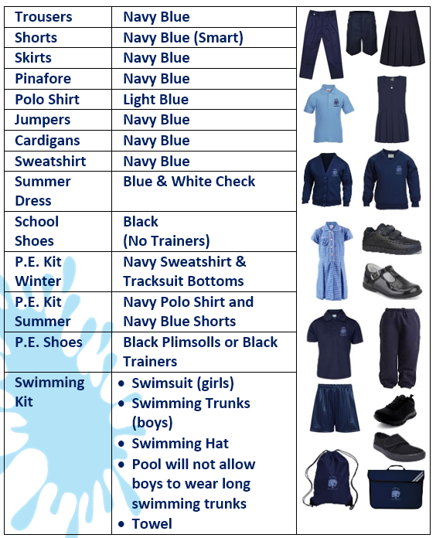

Other support with the cost of school uniforms
Our school runs a scheme to help reduce the cost of the branded items for families whose financial status has meant they have triggered Pupil Premium funding for the school. This scheme offers to contribute up to £50 towards each eligible child’s branded uniform costs per academic year. For further details of this scheme, please speak to the school office.

Religion or beliefs
Some religions and beliefs require their adherents to conform to a particular dress code or to otherwise outwardly manifest their belief. This could include wearing or carrying specific religious artefacts, not cutting their hair, dressing modestly, or covering their head. Pupils have the right to manifest a religion or belief, but not necessarily at all times, places or in a particular manner.

Where a school has good reason for restricting an individual’s freedoms, for example, the promotion of cohesion and good order in the school, or genuine health and safety or security considerations, the restriction of an individual’s rights to manifest their religion or belief may be justified.

Our school is sensitive to the needs of different cultures, races and religions and will act reasonably in accommodating these needs, without compromising important school policies, such as school safety or discipline. It should be possible for most religious requirements to be met within a school uniform policy and our Governing Body will act reasonably through consultation and dialogue in accommodating these.

Pupil non-compliance
Teachers can discipline pupils for breaching the school’s rules on appearance or uniform. This should be carried out in accordance with the school’s published Behaviour & Discipline Policy.

Complaints
Disputes about school uniforms should be resolved locally and should be pursued in accordance with the school’s complaints policy.

Review
This policy will be reviewed every 3 years by the staff and Governing Body of the school, or sooner if deemed appropriate.

Signed: ______________________ (Chair of Governors) Date: _________________

