Ashdon Primary School
Bartlow Road
Ashdon
Essex
CB10 2HB
Tel: 01799584219
Email: admin@ashdon.essex.sch.uk

8th November 2023
Pudsey – Children in Need Biscuit Fund Raising Project

Dear parents and carers,
We would like to make ‘Children in Need/Pudsey Bear’ biscuits to sell on the 17th November at home time. The funds raised will go towards the money we will send to the charity ‘Children in Need’.
We would like to ask parents to help us raise some money for this very noble cause by helping us in providing the ingredients for these biscuits.
We are asking if you would possibly be able to send in the following with your child in order to have enough ingredients to use when we are making the biscuits next Wednesday afternoon.
Could we please ask to have the ingredients by Monday 13th November?
Each child to please bring in:
150g Plain Flour
120g Margarine or Butter
50g Caster Sugar

Kindest regards,
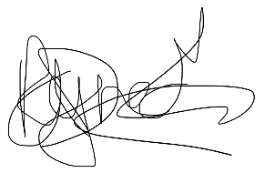
Ms. Reynecke

Headteacher

