1st November 2023

Dear parents and carers,

Thank you for attending the meeting on the 31st October. It was fantastic to see you all. I thought that I would make sure that the information regarding the residential is clear to everyone who attended the meeting, as well as for those who were unable to attend.

The residential will take place from Tuesday 25th June until Friday 28th June at Hautbois Activity Centre in Norwich. The cost for this will be £360 per pupil – accommodation, activities, food, transport and evening activities included.

I am aware that we only going for 3 nights and 4 days, and these are the reasons for this:
- We want to go in the summer time (as other times are just too cold to really enjoy yourselves and if we are lucky, we will get some good weather)
- Residential venues have very limited spaces as some schools book years in advance (if the children feedback that it was a great experience, I will also rebook this for in for the following residential)
- We want to go to a place that has been recommended and rated (this has been highly rated and recommended by many schools)
- Prices for 4 nights and 5 days even in the winter months are now above £650 per pupil and the summer months are extortionate
- The most important aspect for me though is that I would really like everyone to go if possible, and therefore tried to make sure that it is a good quality place/experience as well as more affordable, in the current financial climate.

Accommodation - Reedcutters’ Cabins:
- The Reedcutters’ Village has six 8-bed cabins (that look like wagons), one 6-bed cabin and one 4-bed cabin.
- In six of the huts, there are four bunks (eight beds). Each cabin has space to stow your bags and to hang waterproofs.
- Both the 6-bed and 4-bed cabins can be divided into two separate rooms, suitable for group leaders. These cabins are accessible at both ends.
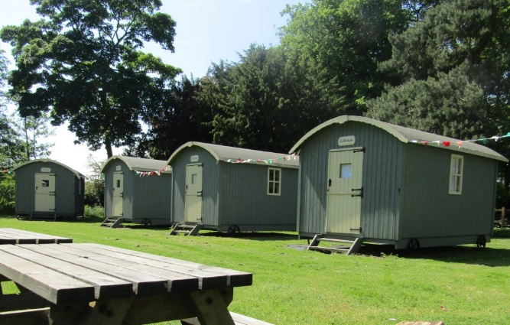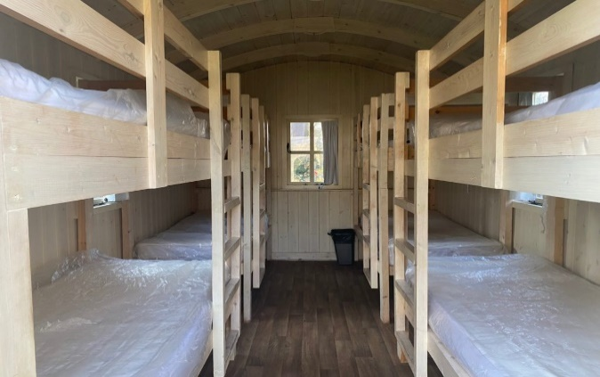

Facilities:
A marquee provides a communal area for groups within the Reedcutters’ Village with tables and chairs. Please note that groups need to bring sleeping bags and pillows in addition to the usual outdoors activity kit list.
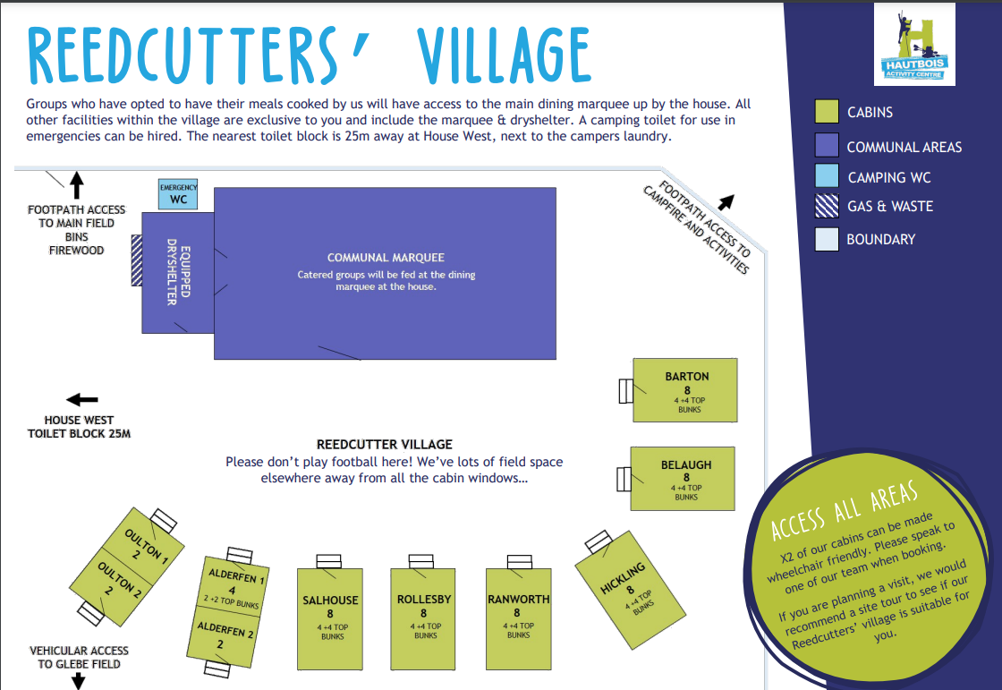
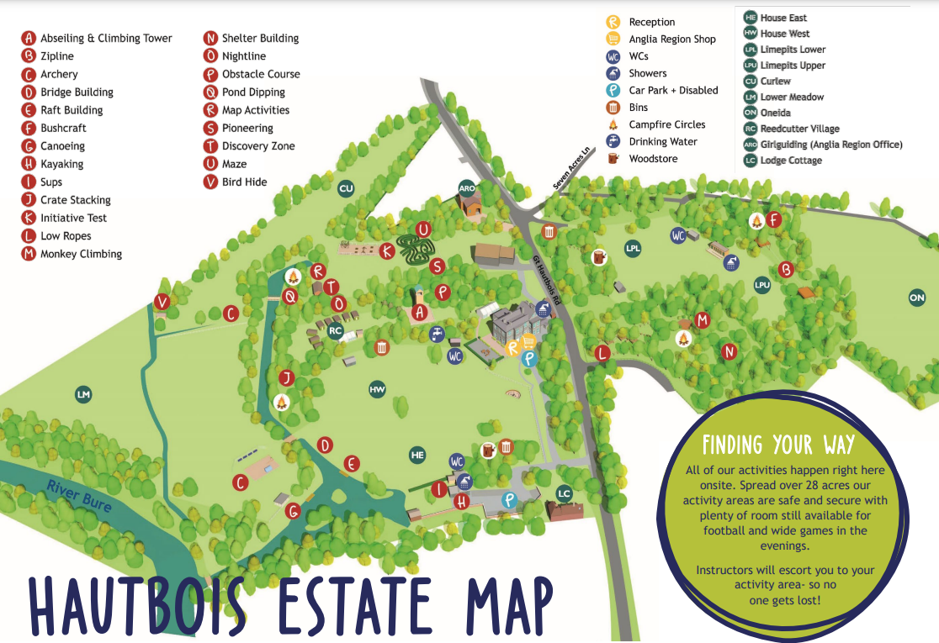
Activity kit list:
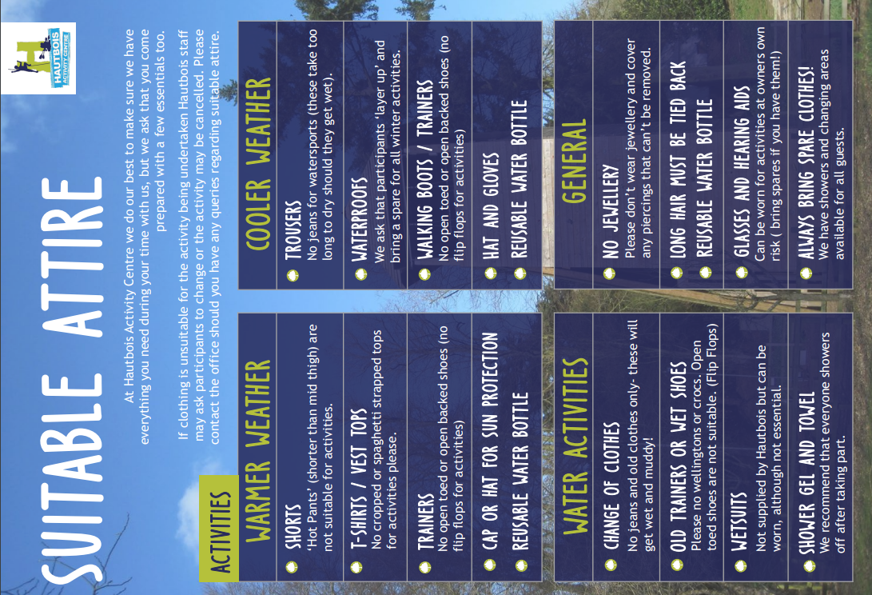
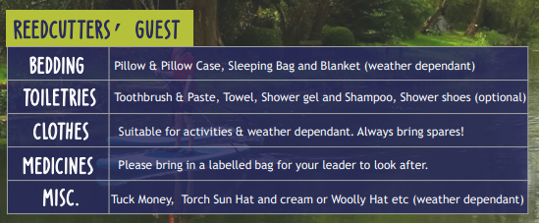
Catering:
Although we had the choice to self cater, we have opted to be catered for during this trip which is already included in the price. For guests being catered for by Hautbois Activity Centre, meals will be served from the large dining marquee near the house, leaving your marquee free for participant use throughout the day.

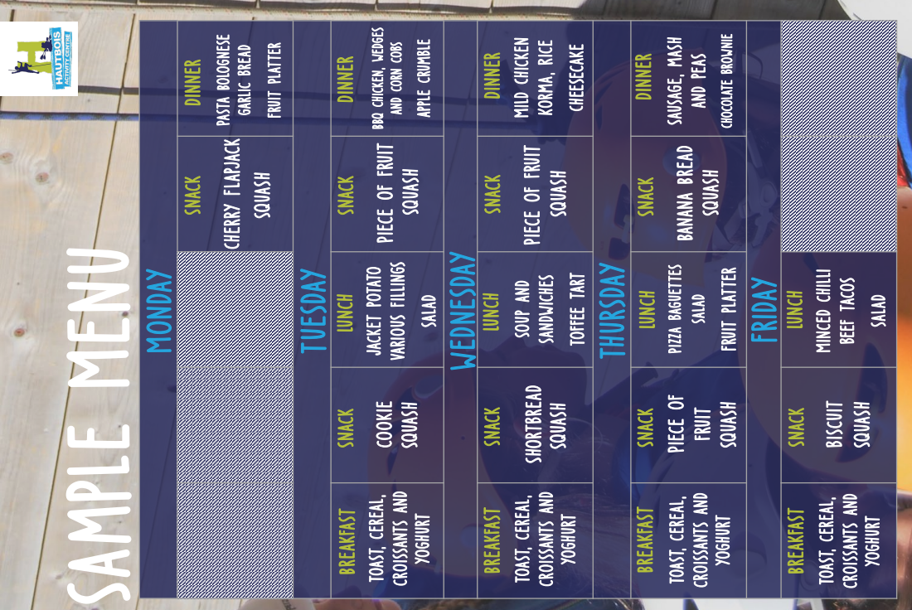

Day of arrival (25th June 2024):

The exact programme of activities that the children will undertake is still being finalised and it will differ from past residentials that the school has taken. I can confirm that we intend to have:

- Games evening
- Cinema evening
- Disco evening

All specialist activities are led by fully qualified instructors.

We will be holding a parents’ meeting nearer the residential visit, explaining all of the arrangements for the visit, such as sleeping, kit lists, the daily routine, medical and dietary needs, etc. You will also be sent letters giving further details, together with any forms that need to be completed.

I am writing to you as early as possible so that we can give parents the maximum time to spread the payments over the coming months. As you will appreciate, the week’s food and accommodation, together with instructors for the daily activities makes this kind of visit significantly more expensive than our usual school trips. If you have any concerns over being able to pay for the residential, please come and speak to me.

If you would like your child to go, you will need to pay an initial of £30 deposit per child via SCOPAY by Friday 1st December 2023. You will then need to pay the instalments listed below. Alternatively, you can pay the whole amount of £360, in one go. All payments should be made using the SCOPAY online payment system.

Initial deposit = £30 by Friday 1st December 2023
2nd payment = £110 by Monday 29th January 2024
3rd payment = £110 by Monday 26th February 2024
Final payment = £110 by Friday 29th March 2024

You should be aware that any payments made are non-refundable, as we are contractually committed to pay Hautbois Activity Centre as well as the coach company. In the unlikely event that your child was seriously ill during the week of the residential, the school would try to negotiate with Hautbois Activity Centre for a refund on your behalf.

In addition to making your first payment towards the cost of the residential, please complete the simple permission form attached and return it to our school office by Friday 1st December.

This is a fantastic opportunity for your child to experience and I do hope they will be able to come. However, I realise that they/you may have concerns, such as sleepwalking, bedwetting, medical needs, or just that they have never stayed away from home before. If you would like to discuss any concerns that you have before making a final decision whether to pay the deposit, then please come and see me.

Yours sincerely,
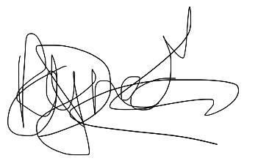
Ms. Reynecke
Headteacher

--------------------------------------------------------------------------------------------------------------------------------------

Hautbois Activity Centre Residential Tuesday 25th June – 28th June 2024

I would like ________________________________________ to attend the Year 5 and 6 residential next academic year.

Signed: ________________________ Name: ______________________________ Date: __________

