Ashdon Primary School
Bartlow Road
Ashdon
Essex
CB10 2HB
Tel: 01799584219
Email: admin@ashdon.essex.sch.uk

9th November 2023
Touch Rugby Tournament and Basketball Tournament (Year 5 & 6)
Dear parents and carers,
Our pupils in Year 5 and Year 6 have the opportunity to take part in two more sporting events this term. We wanted them to take part in as many sporting events this term as they will not be able to take part in that many events once they start preparing for the SATs.

I want to thank all the parents that signed up for events and those who helped us to be able to attend these events by offering to transport our children to events and back.

We have the following two events for this term:

Touch Rugby Tournament on the Thursday 16th November at 13:15 – 15:00 at Katherine Semar
What we will need:
We will need 12 pupils to attend and a minimum of 4 girls must be in the squad
We will need at least 3 parents to please help with transport there and back
We will leave the school at 12:45 in order to be on time for the event

Basketball Tournament on the 30th November at 12:45 – 15:00 at Lord Butler LC
What we will need:
We will need 12 pupils to attend and a minimum of 5 girls must be in the squad
We will need at least 3 parents to please help with transport there and back
We will leave the school at 12:15 in order to be on time for the event

If we do not have enough pupils or parents for these events we will unfortunately not be able to go, so please make sure that you sign up.

The deadline to sign your child up for the event as well as to sign up for helping with transport to the events is Monday 13th November please. If you can sign up earlier – GREAT!

https://forms.office.com/e/dAA4CKmK7j

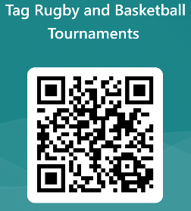
Kindest regards,
Ms. Reynecke

Headteacher

