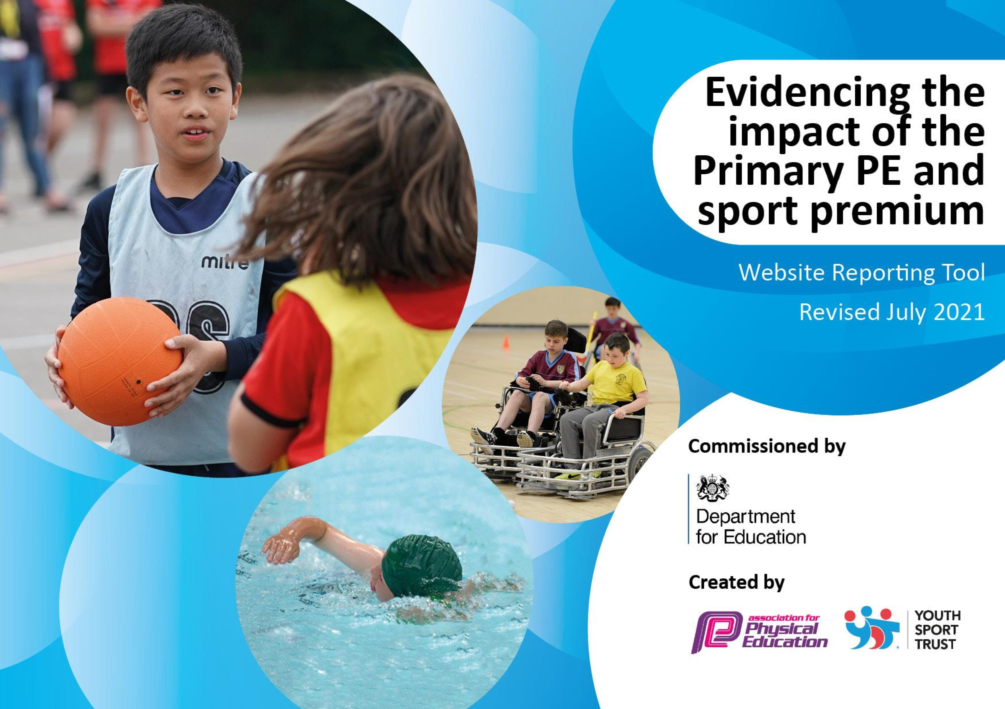

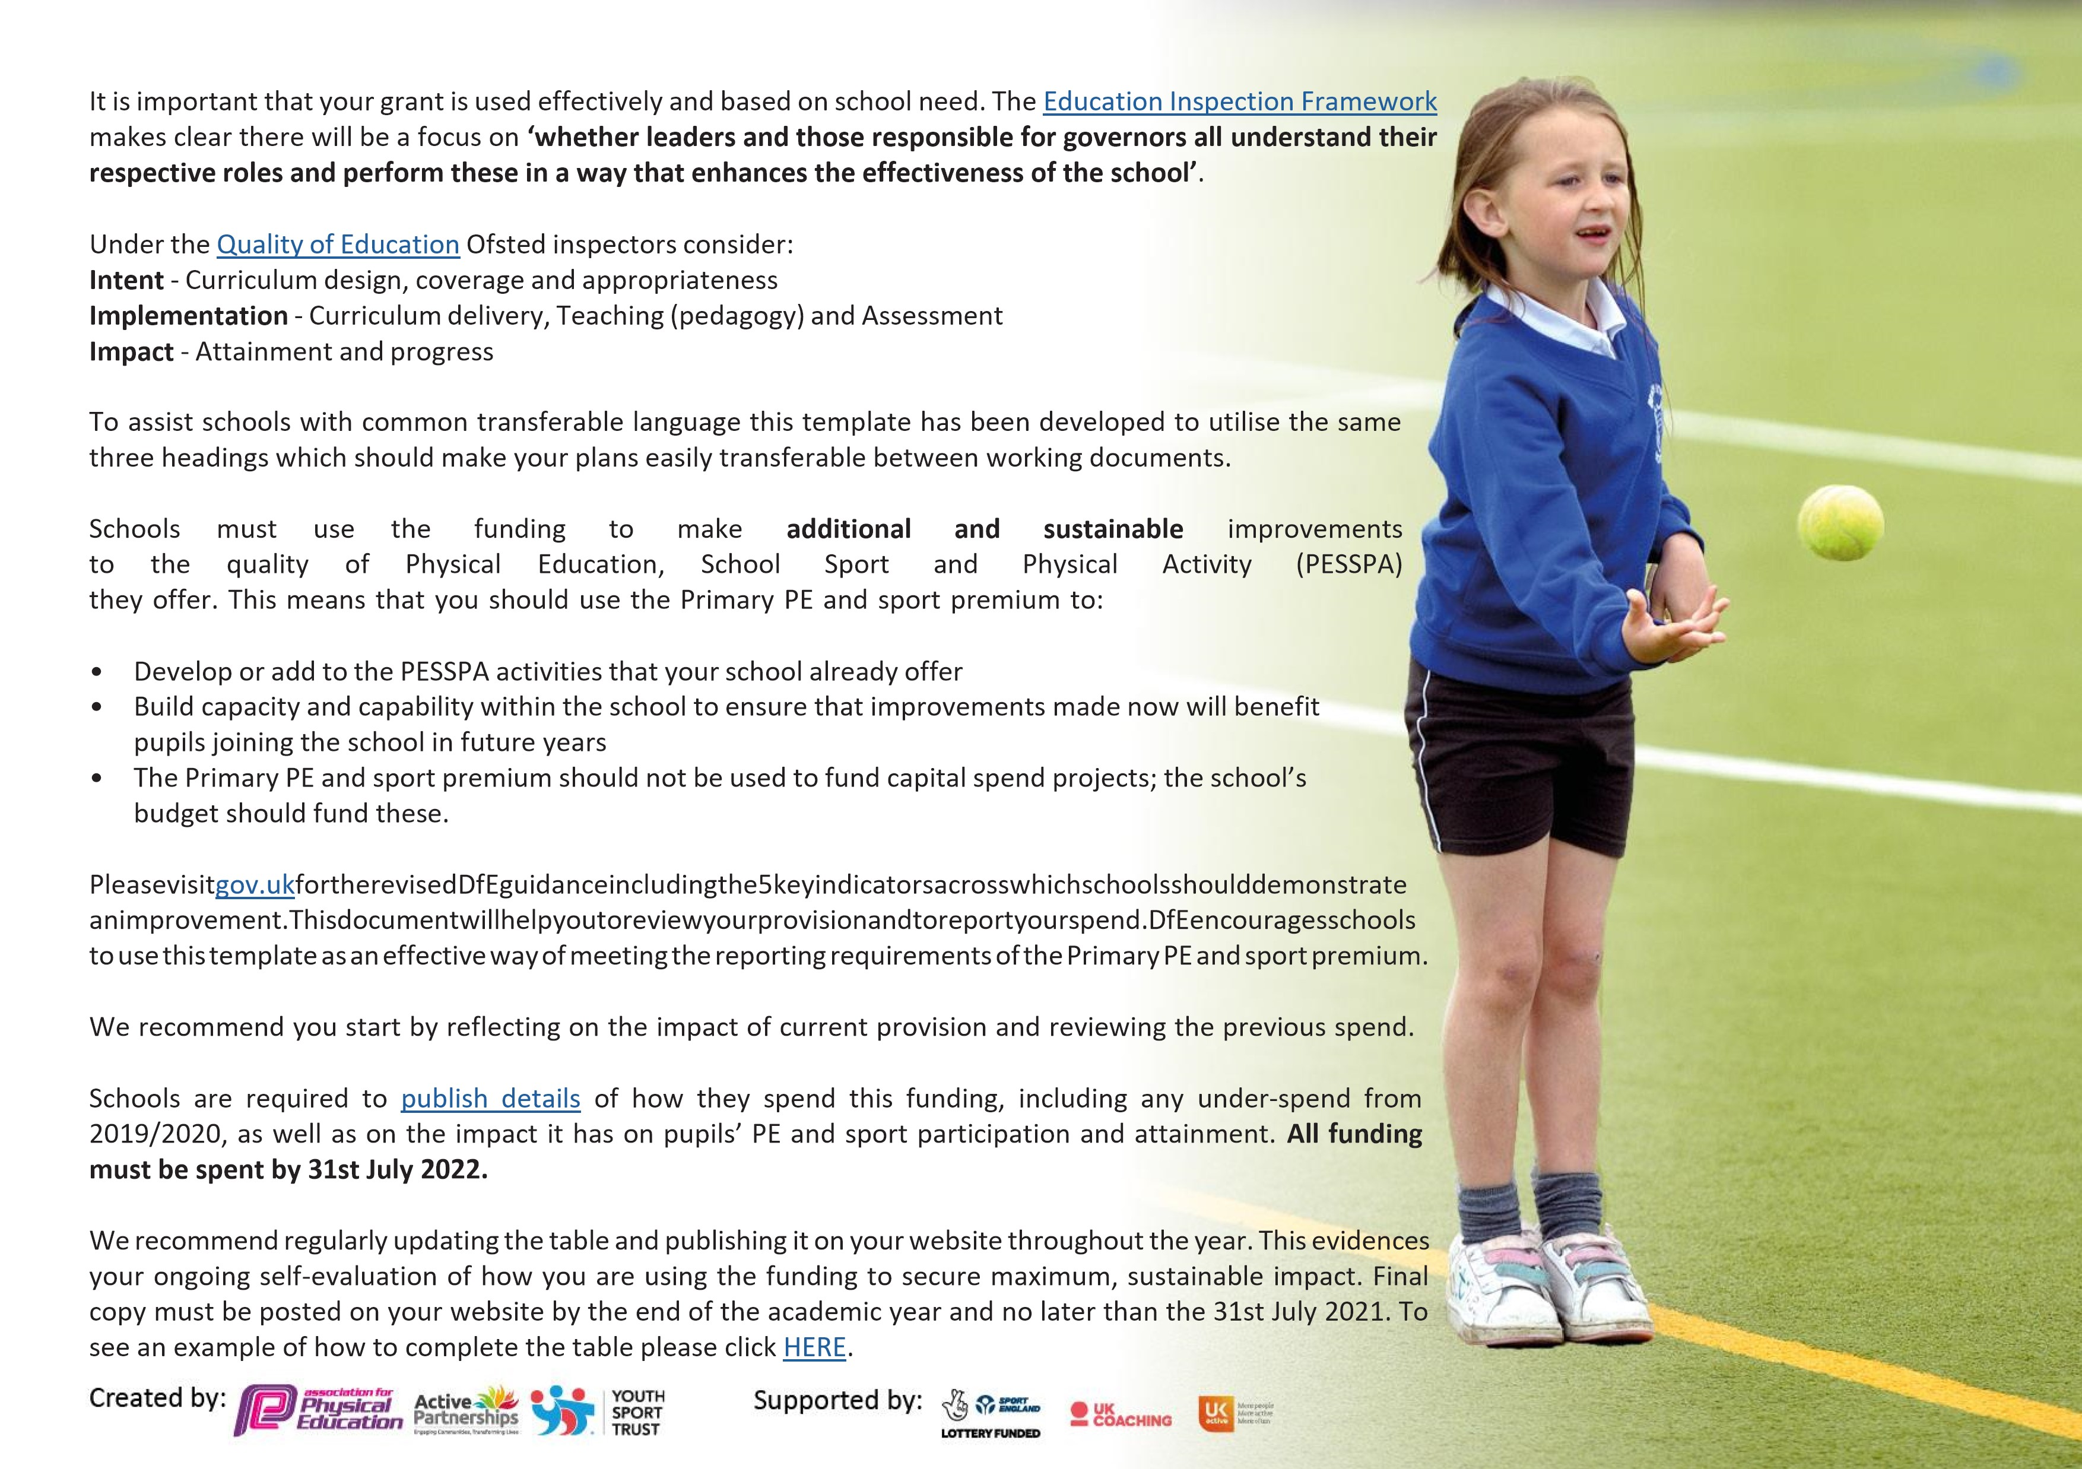
Details with regard to funding
Please complete the table below.

Total amount allocated for 2022/2023 | £16,660
Total amount of funding for 2022/2023. To be spent and reported on by 31st July 2023. | £16,660

Swimming Data
Please report on your Swimming Data below.

Meeting national curriculum requirements for swimming and water safety.

N.B. Complete this section to your best ability. For example, you might have practised safe self-rescue techniques on dry land which you can then transfer to the pool when school swimming restarts.
Due to exceptional circumstances priority should be given to ensuring that pupils can perform safe self rescue even if they do not fully meet the first two requirements of the NC programme of study
What percentage of your current Year 6 cohort swim competently, confidently and proficiently over a distance of at least 25 metres?  N.B. Even though your pupils may swim in another year please report on their attainment on leaving primary school at the end of the summer term 2021. Please see note above | 88%
What percentage of your current Year 6 cohort use a range of strokes effectively [for example, front crawl, backstroke and breaststroke]? Please see note above | 75%
What percentage of your current Year 6 cohort perform safe self-rescue in different water-based situations? | 75%
Schools can choose to use the Primary PE and sport premium to provide additional provision for swimming but this must be for activity over and above the national curriculum requirements. Have you used it in this way? | Yes/No
Action Plan and Budget Tracking
Capture your intended annual spend against the 5 key indicators. Clarify the success criteria and evidence of impact that you intend to measure to evaluate for pupils today and for the future.

Academic Year: 2022/2023 | Total fund allocated: £20,464 | Date Updated: July 2023
Key indicator 1: The engagement of all pupils in regular physical activity – Chief Medical Officers guidelines recommend that primary school pupils undertake at least 30 minutes of physical activity a day in school |  |  |  | Percentage of total allocation:
 |  |  |  | 41.1%
Intent | Implementation |  | Impact
Your school focus should be clear what you want the pupils to know and be able to do and about what they need to learn and to consolidate through practice: | Make sure your actions to achieve are linked to your intentions: | Funding allocated: | Evidence of impact: what do pupils now know and what can they now do? What has changed?: | Sustainability and suggested next steps:
Increase the levels of stamina and fitness of the children. | Equipment to be used with children during either lunch times or break times purchased/maintained.  Children in Reception, Year 1 and Year 2 participate in the ‘Daily Mile’ activity.  Lunch time club offered 1 x per week for Key Stage 2, with PE specialist.  Early Years outdoor equipment purchased. | £5524.18  £0  £2375  £500 | The children regularly engage at breaks and lunch times with a variety of equipment/sports, some structured by adults and/or sports leaders, others unstructured alone or with friends.  Year R/1/2 complete the ‘Daily Mile’ every day, with most children actively participating.  Many children of both genders involved in weekly club, but mostly KS2.  EYFS are actively engaged in outdoors activities and development. 100% met the gross motor skills Early Learning Goal in the end of year assessment. | Utilising sports leaders more frequently and for a wider range of activities. Less equipment should be required going forward after this investment, but some will need replacing over time.  Expand to offer KS2 children participation and encouragement through the ‘Marathon Kids’ scheme.  Possibly offer a 2nd lunch time with a structured sports club.  Consider activities that can help develop fine motor skills, as 60% met this ELG in 2021/22.

Key indicator 2: The profile of PESSPA being raised across the school as a tool for whole school improvement |  |  |  |  | Percentage of total allocation:
 |  |  |  |  | 4.5%
Intent | Implementation |  |  | Impact
Your school focus should be clear what you want the pupils to know and be able to do and about what they need to learn and to consolidate through practice: | Make sure your actions to achieve are linked to your intentions: |  | Funding allocated: | Evidence of impact: what do pupils now know and what can they now do? What has changed?: | Sustainability and suggested next steps:
Profile of PE maintained and improved so that all pupils have opportunities to ‘be their best’ and be taught by specialist teachers.  Using PE as a tool for Growth Mindset. | Kate Burnham to lead dance lessons for all 3 classes.  Jamie Moss to lead ‘Pound’ class for all children.  Ruby Sweetland to lead dance ballet-themed class for KS2.  Mike Mullen, BMX World Champion ½ day visit. Also visit from Olympian and Commonwealth athlete, fencing, Linda Strachan, via the Uttlesford School Sport Partnership. |  | £550  £75  £0  £292.50 | Excellent teacher – children engaged and inspired. Each class produced a finished dance piece that they performed to parent as part of our Spring Festival.  This class helped the children with both their physical exercise but also their rhythmic skills.  The children enjoyed a different style of dance. Unsure how many children will follow up the summer holiday club offered by Ruby.  Mike inspired children with his demonstration and talk about Growth Mindset and his journey from beginner to World Champion. | Invite Kate back for Spring term 2023.  Consider inviting other successful sports men/women to inspire and work with the children.
Key indicator 3: Increased confidence, knowledge and skills of all staff in teaching PE and sport |  |  |  |  | Percentage of total allocation:
 |  |  |  |  | 0.3%
Intent | Implementation |  |  | Impact
Your school focus should be clear | Make sure your actions to | Funding |  | Evidence of impact: what do | Sustainability and suggested
what you want the pupils to know | achieve are linked to your | allocated: |  | pupils now know and what | next steps:
and be able to do and about | intentions: |  |  | can they now do? What has
what they need to learn and to consolidate through practice: |  |  |  | changed?:
The staff feel confident to deliver age and ability appropriate lessons, building on prior skills. | AfPE membership and guidance. | £63.00 |  | A lack of CPD opportunities due Covid restrictions earlier in the academic year. | A greater focus needs to be given to this Key Indicator in the next academic year. Will aim to source a PE specialist to work alongside teaching staff for 1 lesson per week, to upskill them (the other PE lesson is PPA provided a PE specialist, so can’t be funded by the PE & Sport Premium).  Orienteering training for staff, to improve the delivery of this aspect of the curriculum.

Key indicator 4: Broader experience of a range of sports and activities offered to all pupils |  |  |  | Percentage of total allocation:
 |  |  |  | 40.1%
Intent | Implementation |  | Impact
Your school focus should be clear | Make sure your actions to | Funding | Evidence of impact: what do | Sustainability and suggested
what you want the pupils to know | achieve are linked to your | allocated: | pupils now know and what | next steps:
and be able to do and about | intentions: |  | can they now do? What has
what they need to learn and to consolidate through practice: |  |  | changed?:
To introduce the children into new sports, including taster sessions in a range of sports.  The children have a greater range of equipment to use in a variety of sports. | Offer a range of sports-based clubs, including table tennis, netball, athletics and football. Part-fund these clubs to reduce cost to parents.  Work with local sports clubs and introduce children into new sports and provide opportunities for club links.  Additional sports equipment is purchased, to build upon the resources already owned by the school. | £2422.08  £0  £5789 | 2 after-school clubs offered – most places taken. Used PE & Sport Premium to subside cost to parents, so they only paid £1 per session.  Sarah Smith from Saffron Walden Golf Club, led free golf sessions for Year 5/6.  £5789 worth of equipment for PE lessons purchased for both indoors and outdoors sports. This included equipment to replace broken/missing equipment, as well as additional expenditure on new types of equipment to expand the curriculum offer, e.g., Golfway resources and orienteering resources. | Both clubs offered were for KS2 age range, therefore we want a 3rd club to offer sport for KS1.  Invite further sports clubs to our school, to work with the children.  Orienteering – map the school site professionally and train up staff.
Key indicator 5: Increased participation in competitive sport |  |  |  | Percentage of total allocation:
 |  |  |  | 14%
Intent | Implementation |  | Impact
Your school focus should be clear | Make sure your actions to | Funding | Evidence of impact: what do | Sustainability and suggested
what you want the pupils to know | achieve are linked to your | allocated: | pupils now know and what | next steps:
and be able to do and about | intentions: |  | can they now do? What has
what they need to learn and to consolidate through practice: |  |  | changed?:
To provide a wealth of opportunities for all abilities to compete in competitive sport. | Annual membership fee of the Uttlesford School Sports Partnership.  Cost of transport and staff for each competition (E.g., supply staff to release members of our staff or coach/bus costs). | £580  £2293.40 | USSP organised many competitions, but the school was unable to attend them due to significant transport problems, see below.  Only £165.80 spent to go to the USSP swimming gala, as no transport could be obtained for other local events (lack of drivers).  Due to limited number of staff, staffing an issue when needing to send less than a class to an event. | Investigated possibility of buying or loaning a minibus for travel. Will try to book travel up several terms in advance, in hope of securing transport ahead of other schools.  Pay for sports instructors and/or supply teachers to take the children and officiate at events.

Signed off by
Head Teacher: | Simon Rance/Marne Reynecke
Date: | 22/7/2023
Subject Leader: | Simon Rance/Marne Reynecke
Date: | 22/7/2023

